Activity 1 -Subquery Part01
Ex. n.1
SELECT
employee_id,
first_name,
last_name,
salary
FROM
employees
WHERE salary =
(SELECT
MIN(salary)
FROM
employees);

RESULT:


Ex n.2
SELECT
employee_id,
first_name,
last_name,
salary
FROM
employees
WHERE salary >
(SELECT
AVG(salary)
FROM
employees)
ORDER BY
first_name,
last_name;
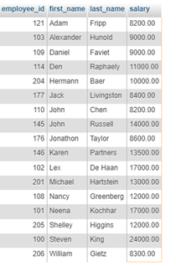

Ex. n. 3
SELECT
employee_id,
first_name,
last_name,
salary,
department_id
FROM
employees
WHERE
EXISTS( SELECT
*
FROM
employees
HAVING
department_id = 6
AND
salary < AVG(salary) )
ORDER BY
first_name,
last_name;

RESULT:
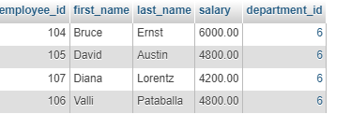

Ex. n. 4
SELECT
employee_id,
d.department_name,
first_name,
last_name
FROM
employees e
INNER JOIN departments d ON d.department_id = e.department_id
WHERE EXISTS ( SELECT
*
FROM
departments
HAVING
department_name = 'IT');

RESULT:
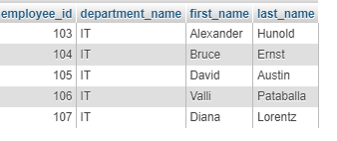

Ex. n. 5
SELECT
e.employee_id,
e.first_name,
e.last_name
FROM
employees e
INNER JOIN
dependents d ON d.employee_id = e.employee_id
WHERE e.employee_id = (SELECT
employee_id
FROM
dependents
WHERE
first_name = 'Jennifer'
AND
last_name = 'King');

RESULT:


